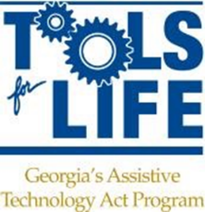
DBHDD CHECKLIST

___ Invitation Letter Given
___ Signed Consent Document for Enrolling Adult Participant in a Research Study
(Left one with individual)
___ Signed AMAC Assistive Technology Services Agreement Form- Internal permission
(Left one with individual)
___ Signed Ga Tech Model Release- External permission
(Left one with Individual)
___ Completed survey on app if participant is able to take
___ Completed paper survey by caregiver if individual is unable to take
___ Information added to Person DSR in TFL Database
___ Completed Task
___Signed papers sent to TFL

