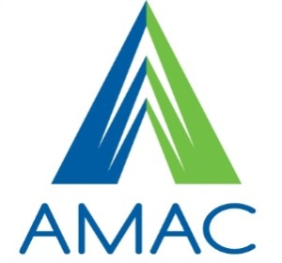
Accessibility Solutions & Research Center

Assistive Technology Device Loan Agreement

This agreement is to document the loan of Assistive Technology Devices as listed to the signed individual below. The signee acknowledges their responsibility for the return of the devices in good working order at the end of the loan period.

Item Description | Item Inventory Number | Return Date

Name | Email Address |  | Phone Number
Address
(Customer) Signed: |  | Date:
Issued By: |  | (Employee) Signed:

